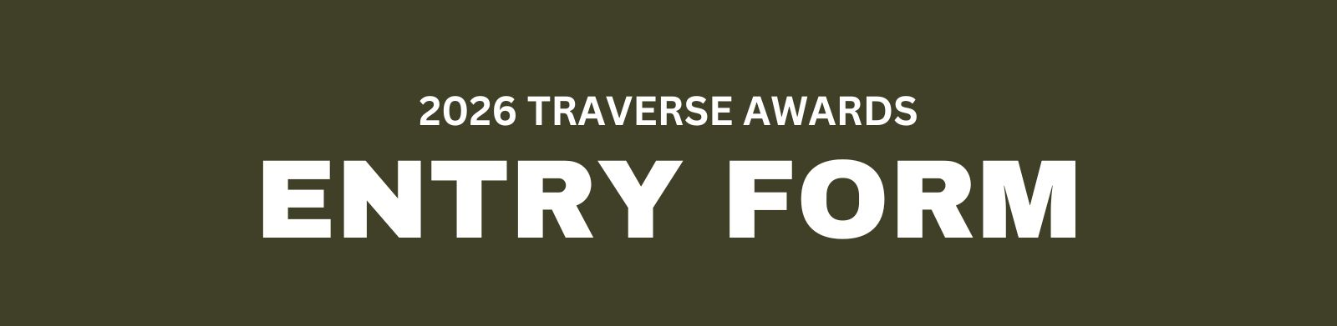

All entrants must complete this entry form. You will need to have ONE sheet for each entry. All entries must be submitted by Wednesday, August 5, 2026. A late fee of $30.00 will be applied to submissions after August 5, and no submissions will be accepted after August 12, 2026 at 5:00 p.m. EST.

Email all forms and materials to Katherine Bowman at katherine.bowman@ktia.com and Sarah Brock at sarah.brock@ktia.com. You will receive a confirmation email when your information has been received.

PROJECT SPECIFICS

ORGANIZATION NAME:
TITLE OF ENTRY:
ENTRY DIVISION:
ENTRY CATEGORY:
PROJECT BUDGET:
LAUNCH DATE:
END DATE:

PROJECT INFORMATION

Please use the space below to fully describe your project under the three criteria of
CONCEPT, CREATIVITY and RESULTS/IMPACT. You have up to 250 words per section.

Note that to receive points within in each criterion, you must include specific information which addresses each. Failure to include information specific to each criterion will result in 0 points awarded for that specific criterion.

CONCEPT
Explain the concept and goals of the project.

CREATIVITY
Describe the project in creative terms in regard to project design, development, implementation and as applicable, include elements of originality, innovation and graphic creativity.

RESULTS/IMPACT
Describe as specifically as possible what the project achieved and include quantified results to the extent possible. If the project does not have quantifiable results, be sure to include what impact was derived.

