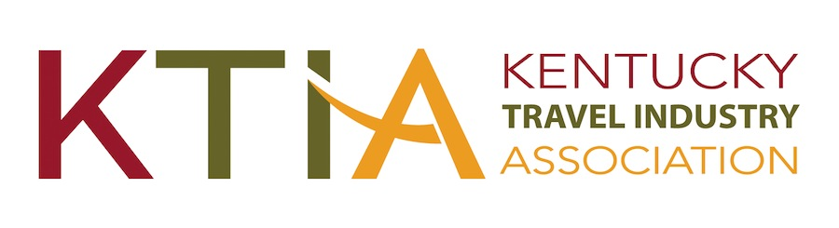

For more information, contact:

Hank Phillips, President/CEO at (502) 223-8687

Hank.Phillips@ktia.com

931 East Main Street

Frankfort, Kentucky 40601

Ph. (502) 223-8687

**FOR IMMEDIATE RELEASE**

**Frankfort, KY, November 20, 2024**

***(Organization)* Wins Prestigious Tourism Award*(s)***

***(Organization)*** has received a ***(adapt for use for multiple awards)*** Traverse Award for Excellence in Kentucky Tourism from the Kentucky Travel Industry Association. The award was presented during the 2024 Kentucky Travel Industry Annual Conference held November 13-15 at the Northern Kentucky Convention Center in Covington.

***(Organization)*** received a ***(Level(s))*** Traverse for its ***(Name or description of entry)*.** According to, ***(Organization’s spokesperson),*** “***(Comments).”***

Kentucky travel and tourism businesses and marketing organizations vie for Traverse Awards in 11 categories. A panel of out-of-state tourism industry experts judge the Traverse Awards. Award criteria include concept, creativity, results and impact.

According to KTIA president & CEO Hank Phillips, “Even more than the record breaking 227 award entries received this year, our judges were struck by the entries’ quality and creativity and by their positive impact on communities throughout the Commonwealth. The 2024 Traverse Awards competition was by far the most intense ever, and clearly reflects why tourism in Kentucky continues its record setting pace in visitation and economic impact.”

The Kentucky Travel Industry Association represents and serves all segments of Kentucky’s tourism industry, which despite the pandemic’s severe impact, contributed $13.8 billion to Kentucky’s economy in 2023. The nearly 1000-member association engages in advocacy and provides its members with education, information and business development opportunities. The association also works to inform the public of the enormous economic, employment and tax revenue contributions tourism makes to the people of Kentucky.