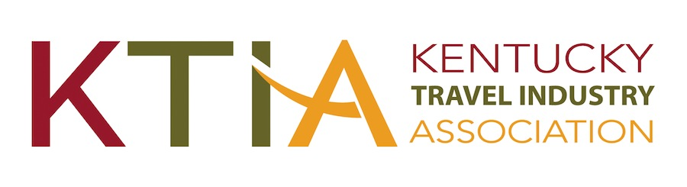
For more information, contact:
Hank Phillips, President/CEO at (502) 223-8687
Hank.Phillips@ktia.com
931 East Main Street
Frankfort, Kentucky 40601
Ph. (502) 223-8687

FOR IMMEDIATE RELEASE

Frankfort, KY, November 14, 2023

(Organization) Wins Prestigious Tourism Award(s)

(Organization) has received a Traverse Award for Excellence in Kentucky Tourism from the Kentucky Travel Industry Association. The award was presented during the 2023 Kentucky Travel Industry Annual Conference held November 8-10 at the Sloan Convention Center in Bowling Green.

(Organization) received a (Level(s)) Traverse for its (Name or description of entry). According to, (Organization’s spokesperson), “(Comments).”

Kentucky travel and tourism businesses and marketing organizations vie for Traverse Awards in 11 categories. A panel of out-of-state tourism industry experts judge the Traverse Awards. Award criteria include concept, creativity, results and impact. A total of 199 entries were submitted from throughout Kentucky for the 2023 competition.

According to KTIA president & CEO Hank Phillips, ”With nearly 200 entries and based on the judges’ comments about the across the board high quality of the entries, the 2023 Traverse competition was as close as it was intense. The larger picture of the awards is how they reflect the results-oriented talent and creativity that exists throughout Kentucky’s tourism industry. That talent and creativity last year attracted over 75 million Kentucky visitors bringing with them the many benefits tourism provides to the people of the Commonwealth.”

The Kentucky Travel Industry Association represents and serves all segments of Kentucky’s tourism industry, which despite the pandemic’s severe impact, contributed $12.9 billion to Kentucky’s economy in 2022. The nearly 1000-member association engages in advocacy and provides its members with education, information and business development opportunities. The association also works to inform the public of the enormous economic, employment and tax revenue contributions tourism makes to the people of Kentucky.

