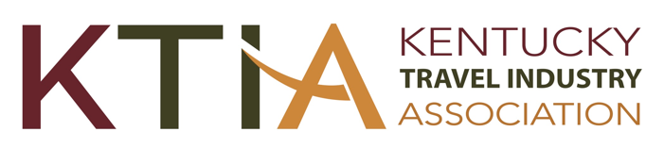
2024 Legislative Agenda

Tourism Marketing resources

Preserve the 1% Transient Room Tax for Marketing All of Kentucky
These funds are intended for statewide tourism marketing and should not be redirected or diverted for other purposes.

Local Transient Room Tax: No Centralized Collection System
Such a system would cost $2.4 million and currently “there are no legal or technological barriers prohibiting online facilitators from complying with their collection and reporting responsibilities to Kentucky’s local transient jurisdictions.” Source: KY Department of Revenue

Expand City Eligibility to Enact Restaurant Tax
All cities should be permitted to enact the restaurant tax IF doing so preserves current requirements in cities that currently have it and a reasonable portion of the monies from a new tax are dedicated to the city’s tourist commission.

A Welcoming Kentucky

No Legislation That is Not Welcoming to All Visitors
Kentucky’s welcoming attitude is a driving force in attracting a large and diverse array of visitors and the economic benefits that result. Legislation perceived as discriminatory that could trigger actions damaging to visitation (boycotts, cancellations, etc.) should not be enacted.

Address Human Trafficking
Where this horrific criminal activity occurs is often tourism related (hotels, major events, etc.). Enact legislation that continues to more fully and effectively address human trafficking.

Bourbon Visitor Experiences

Allow Limited Self-distribution for Craft Distillers
Craft distillers should be permitted to self-distribute a limited quantity of their bourbon.

Expand Satellite Tasting Rooms
Expand from one satellite tasting room per distillery on-site visitor center to two satellite tasting rooms per visitor center.

Actively Monitoring

The following are issues that will evolve over the course of the 2024 session that potentially have tourism implications and that KTIA will be actively monitoring with positions to be adopted later if warranted:
- Artificial Intelligence (AI)
- Data Privacy
- Local Tax Reform
With these and other issues that may emerge, KTIA’s active monitoring will be to communicate tourism perspectives to legislators, including ways to benefit the industry and to avoid negative actions, such as any that are unnecessarily restrictive, burdensome or otherwise adverse to tourism interests.

